**Learning about urban mitigation solutions**

William F. Lamb, Felix Creutzig, Jan C. Minx

**It is often remarked that cities could lead the way in climate change mitigation and provide a test-bed for policy experiments and social change. In this regard there is already a large body of case study literature to learn from and translate into different urban contexts** 1**. However, a number of practical and conceptual challenges stand in the way. First, the literature tends to focus on cases in large, wealthy and globally connected cities, despite the majority of the global population residing in much smaller agglomerations. Second, a comprehensive overview of which mitigation topics have been researched for what cities is currently lacking. Third, questions of comparability and generalisability are central to learning about urban policies, particularly among small developing country cities, yet such questions remain under-explored in practice. Here we propose solutions to these issues, bringing together natural language processing, typology creation and systematic review methods.**

Cities experience similar dynamics of urbanisation and agglomeration 2, are faced with structurally comparable decarbonisation challenges 3, and are increasingly interconnected through trade, globalisation, and coordinated social or political movements 4,5. The opportunities for comparative research across cities are therefore widely discussed 6,7, with much of the urban climate change mitigation literature dedicated to case studies and horizontal comparisons of local actions.

As in previous IPCC reports, the 6th Assessment Cycle will include a dedicated chapter on urban systems. Although there have been some efforts so far to aggregate knowledge on cities 8, AR6 will be an important opportunity to systematically learn from the urban case study literature. Doing so would satisfy increasing demands for a solutions orientation in the IPCC that is simultaneously *contextual* (which policies and actions work under which conditions?) and *generalizable* (what can cities learn from mitigation experiments that have been attempted elsewhere?).

However, major practical innovations and a shift in focus may be needed if the IPCC is to avoid representing the urban case study literature as a patchwork of anecdotes. In the first instance, the published literature on climate change is following an exponential growth trend 9 and the urban mitigation field is no exception 1. Amid this growing weight of literature, there is a risk that attention will only be paid to highly visible, contentious, or successful examples of urban climate change mitigation. Failures risk being overlooked, despite the opportunities they provide for learning – for instance about the political economic barriers to transitions. In addition, it is often claimed that urban research tends to focus on large, wealthy cities in the global North, at the expense of rapidly urbanising areas in Asia and Africa 2,8,10.

Cities also offer conceptual challenges in knowledge aggregation. These relate to the notorious problem of systematising urban physical boundaries for comparison (REF); or to the justified selection of topics that are ‘urban’ and not simply general social or global processes 2. Considerable attention is therefore paid to the contextual factors that shape different urban experiences, including economic development, political authority, infrastructure choices and pathways, and so forth (…).

In this paper we take stock of the urban mitigation research so far, assessing the extent to which these issues remain unresolved and suggest ways forward. To this end we obtain a sample of articles using a simple search query that combines synonyms for “cities” and “mitigation” in the Web of Science (WOS) literature database (Table 1). From the titles and abstracts of these papers we extract a basic but informative piece of meta-data – which cities are mentioned in the literature? For each city thus mentioned we are able to: (1) count the number of articles it receives; (2) observe the strength of citations of these articles; (3) identify which other cities are mentioned in the same article (indicating comparative research); and (4) identify the topics under investigation in each city. In the following sections we aggregate these results by city sizes, regions …

|  |  |
| --- | --- |
| City synonyms | Mitigation synonyms |
| TS = ("urban*" OR "municipal" OR "city" OR "cities" OR "metropolitan") | AND TS = (“low carbon” OR "decarboni*ation" OR (“energy” OR “carbon” OR “CO2” OR “GHG” OR “greenhouse gas” OR “climat*”) NEAR/3 ("mitigation" OR "reduc*" OR "polic*" OR "governance")) |
|
|

Table : Search query for urban climate mitigation literature. The two strings are combined and entered in the Web of Science ‘advanced search’ function.

**Which cities do we know about?**

Of the approximately 6000 articles identified in WOS using our query, 2203 directly refer to an urban location in the abstract or title. An article is double counted if it mentions multiple cities. We assume that all such articles are ‘case studies’ on the cities in question, although this may not always be the case.

Aggregating the mentioned cities by size, a spread of case study research can be seen across different city types (Figure 1), with up to 400 articles on ‘mega-cities’ (population above 10 million) and a peak of 622 articles on medium-sized cities (1-5 million). A small number of cities at the top of the population distribution receive particular attention in the literature: Beijing (162 articles), New York City (71), Shanghai (65) and London (57). Other cities are mentioned in fewer than 50 articles each.

The relative weight of the medium-sized population category can be explained by the prolificacy of these cities worldwide, but also the dataset we use (REF), which constrains urban population size to municipal boundaries. If we consider the agglomerations surrounding cities such as Chicago, Los Angeles and Paris, then the distribution shifts towards mega-cities (x vs x; SI text Fig 1).

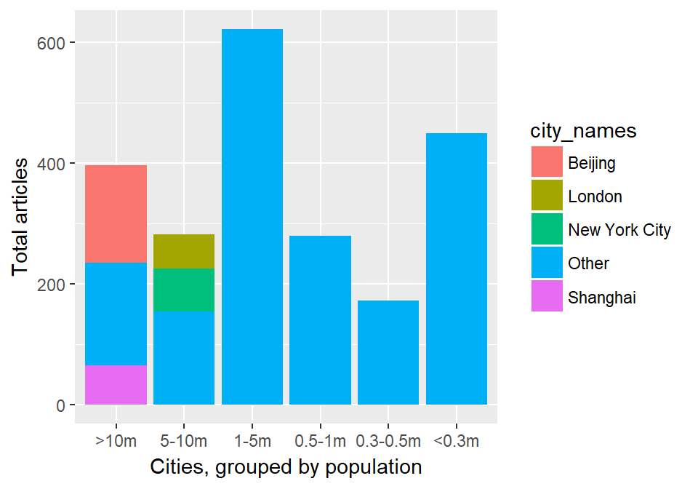

Figure : Urban climate mitigation articles, counting by city size. The data refers to municipal boundaries, not agglomerations.

Considering the global population distribution across different city types, is the current focus of research justified? Figure 2 shows, by region, the proportion of articles, article citations and inhabitants for each city size. For instance, in Asia, articles on mega-cities account for almost 50% of all urban mitigation articles. In addition, articles on these cities gather approximately 50% of all citations relative to smaller cities in Asia. These results sit in stark contrast to the low proportion of mega-city inhabitants in this region (10%), and the high proportion of inhabitants of small agglomerations of less than 300,000 persons (33%). Similar mismatches can be seen in Europe, Latin America and North America. Indeed, citations patterns can exacerbate the literature bias – downplaying the importance of small cities even where the literature is available (Europe).

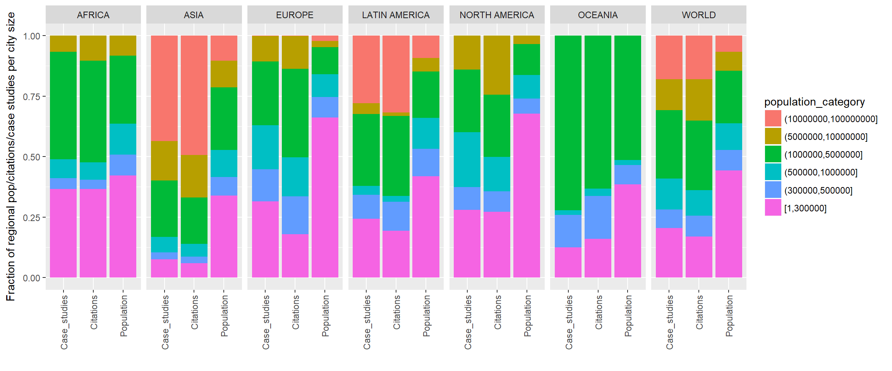

Comparing the quantity of research between regions (SI Text Fig 2), there is a clear dearth of literature on cities in Africa and Latin America (just 4% and 5%, respectively), even though the urban population in these regions exceed that of North America – and Africa is projected to surpass Europe by 2030. Although Asia is generally well represented in the literature (38% of all articles), it is arguably understudied in the context of the global urban population share (47%, projected to increase to 54% by 2030), and the fact that the majority of identified studies are specific to Chinese cities. By contrast, Europe and North America receive an outsized share of articles (25% and 23%) and citations (26% and 29%), despite their low shares of the global urban population (17% and 9%, respectively).

In sum the literature demonstrates clear biases: larger cities in Europe and North America tend to be favoured in case study research, as well as a small number of specific mega-cities. Citations follow suit and even exacerbate inter-city and inter-regional differences. These trends mirror concerns that the IPCC underrepresents developing country author teams and research, calling into question both the scientific credibility and claimed comprehensiveness of the report.

**What topics do we know about?**

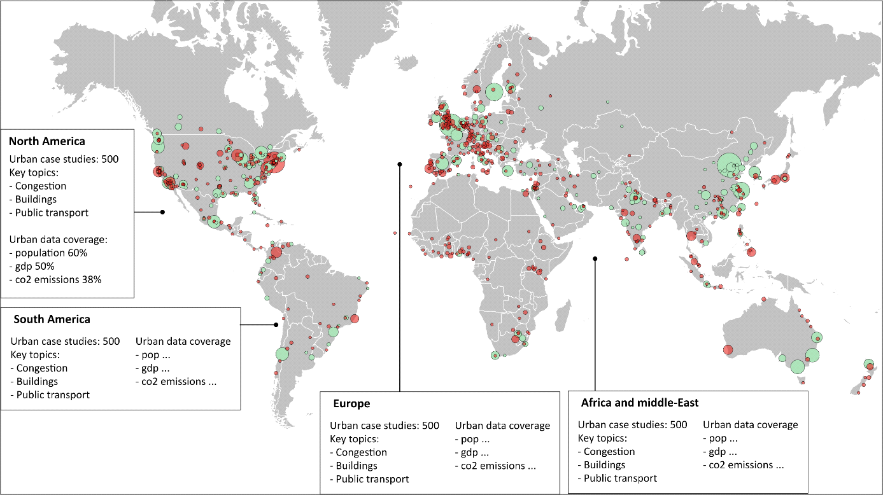

**How do we progress towards an assessment of cities?**

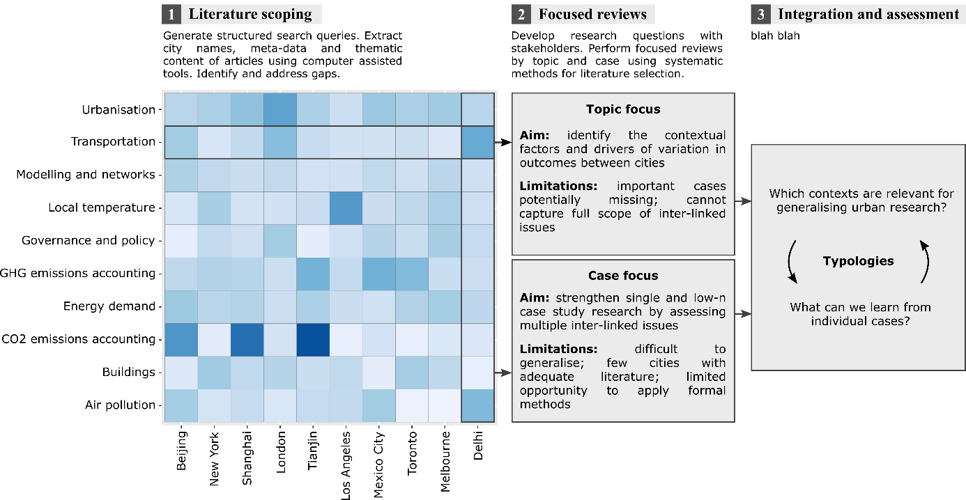

1. Lamb, W. F., Callaghan, M. W., Creutzig, F., Khosla, R. & Minx, J. C. The literature landscape on 1.5°C Climate Change and Cities. *Curr. Opin. Environ. Sustain.* **30,** 26–34 (2018).

2. Scott, A. J. & Storper, M. The nature of cities: The scope and limits of urban theory. *Int. J. Urban Reg. Res.* **39,** 1–15 (2015).

3. Creutzig, F., Baiocchi, G., Bierkandt, R., Pichler, P.-P. & Seto, K. C. Global typology of urban energy use and potentials for an urbanization mitigation wedge. *Proc. Natl. Acad. Sci.* (2015). doi:10.1073/pnas.1315545112

4. Sudmant, A., Gouldson, A., Millward-Hopkins, J., Scott, K. & Barrett, J. Producer cities and consumer cities: Using production- and consumption-based carbon accounts to guide climate action in China, the UK, and the US. *J. Clean. Prod.* **176,** 654–662 (2017).

5. Global Covenant of Mayors. Global Covenant of Mayors for Climate & Energy. (2017). Available at: http://www.globalcovenantofmayors.org. (Accessed: 10th November 2017)

6. Grandin, J., Haarstad, H., Kjærås, K. & Bouzarovski, S. The politics of rapid urban transformation. *Curr. Opin. Environ. Sustain.* **31,** 16–22 (2018).

7. Bulkeley, H. & Castán Broto, V. Government by experiment? Global cities and the governing of climate change. *Trans. Inst. Br. Geogr.* **38,** 361–375 (2013).

8. Castán Broto, V. & Bulkeley, H. A survey of urban climate change experiments in 100 cities. *Glob. Environ. Chang.* **23,** 92–102 (2013).

9. Minx, J. C., Callaghan, M., Lamb, W. F., Garard, J. & Edenhofer, O. Learning about climate change solutions in the IPCC and beyond. *Environ. Sci. Policy* **77,** (2017).

10. Robinson, J. Cities in a World of Cities: The Comparative Gesture. *Int. J. Urban Reg. Res.* **35,** 1–23 (2011).

**Supplementary information**

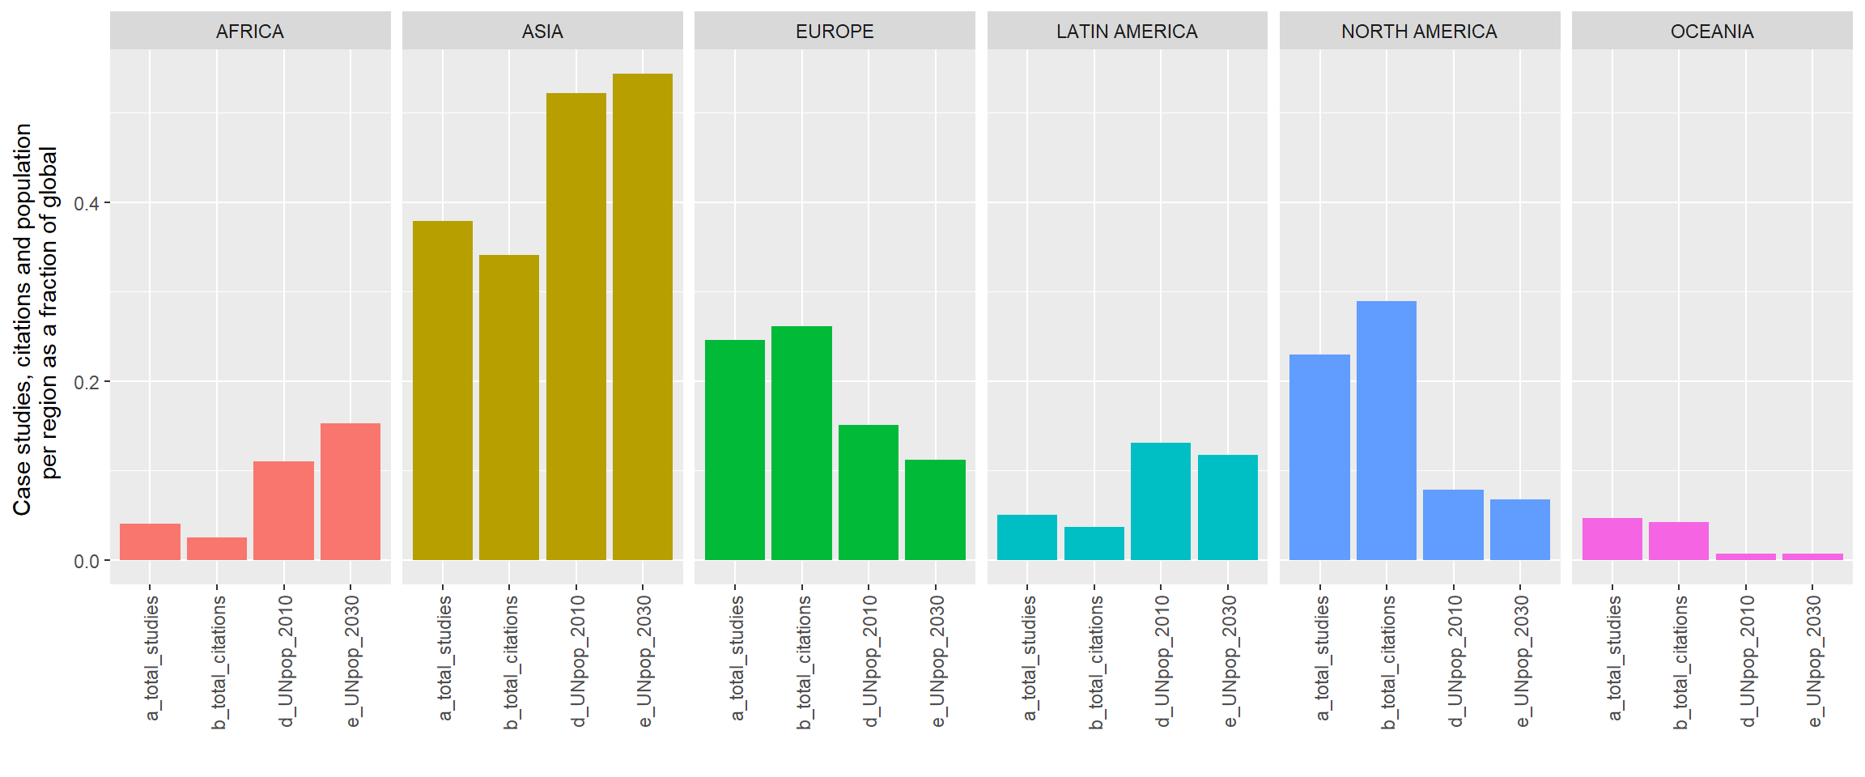

Fig 2: Regional biases in urban case study research and citations